Lairdsland Primary School

Behaviour and Relationships Policy
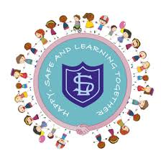

2026



Contents

Section |  | Page
1 | Introduction | 2
2 | Our Approach to Behaviour and Relationships | 3
3 | Universal Approaches | 4
3.1 | Values-Based Approach | 4
3.2 | Stepped Actions | 5
3.3 | Restorative Approach | 7
3.4 | Natural Consequences | 7
3.5 | Nurture | 8
3.6 | CIRCLE Framework | 9
3.7 | Trauma-Informed Approach | 8
3.8 | Anti-Bullying | 10
4 | Targeted Approaches | 11
4.1 | Nurture Class | 11
4.2  4.3 | Family Learning Services  Services | 11  11
5 | Celebrating Success | 11
6 | Roles and Responsibilities | 12
6.1 | The Role of Staff | 12
6.2 | The Role of Pupils | 12
6.3 | The Role of Parents and Carers | 12
 | Appendix 1. Working Together Letter | 13

- Introduction

‘In East Dunbartonshire’s Schools, the development of relationships and skilled support for children and young people to manage their behaviour is essential. The whole school community endeavours to create a caring, nurturing, optimum learning environment, which promotes creativity, whereby everyone feels empowered, supported, and loved. Universal strategies will be in place to enable structured, safe, and predictable environments. Schools will utilise well-planned, targeted interventions to meet learner needs.’ - This policy sets out how this is achieved at Lairdsland Primary School.

Our Vision
A school where we work together to make sure everyone feels happy, safe, supported, and encouraged to do their best.

Our Promise

- We will listen to you
- We will value you
- We will help and challenge you to be the best you can be

Our Values

Welcoming

Everyone belongs at Lairdsland Primary.
- We are a welcoming and inclusive school
- Everyone is valued and respected
- We celebrate our differences and diversity
- We make sure everyone gets the support they need to learn
- We help each other feel safe, confident, and ready to learn
- We understand that our school is part of a wider community and world

Kindness

We treat everyone with kindness, respect, and care.
- We use kind words and actions
- We listen to each other and take turns
- We show empathy and understanding; we are honest
- We help others when they need it
- We think about how our behaviour affects others
- We work together to solve problems calmly and fairly

Teamwork

At Lairdsland, we are one team. Children, staff, and families work together to make our school a happy and positive place.
- We help and support one another
- We value effort and hard work
- We learn and succeed together
- We celebrate our achievements
- We are responsible and resilient – we keep trying and learn from our mistakes
- We encourage leadership and responsibility at all levels

- Our Approach to Behaviour and Relationships
Our Values are at the centre of building and supporting positive behaviour and relationships. Our approach to supporting and managing behaviour and relationships reflects a commitment to understanding the underlying factors that influence behaviour.
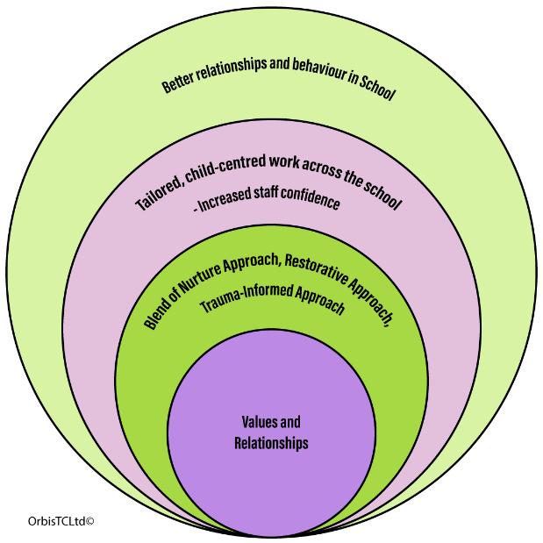
We recognise that behaviour support is not ‘one size fits all’. All children benefit from universal supports built into our everyday practice, promoting positive behaviour through clear expectations, consistent language, and strong relationships. However, some children may also require targeted approaches tailored to their individual needs.

We select the right strategies from our ‘toolbox’ – this is our range of approaches and tools we have been trained in - based on the needs of each child, ensuring that interventions are appropriate and supportive. Central to every approach - whether universal or targeted - is the relationship we build with the child.
We know that any intervention is more successful when it is delivered within a caring, trusting, and respectful relationship. This reflects the expectations set out by East Dunbartonshire Council, and this policy sets out our Universal and Targeted Approaches at Lairdsland.
Children’s Rights
Our commitment to promoting Children’s Rights underpins our Vision and Values. This means that our pupils have, in line with the UNCRC, the right to not be discriminated against, the right to be included in decisions involving them, the right to be kept safe from harm and the right to be listened to.

Child’s Voice

As part of our commitment to Children’s Rights, we ensure that our children have a voice. As we developed this policy, we spoke with our pupils, and they told us they wanted a school where people are kind, where things are fair, and they feel listened to.

- Universal Approaches
3.1 Values-Based Approach
We actively recognise and reward behaviour that reflects our values. We are explicit about what our values mean and how positive behaviour can demonstrate them in everyday actions. Our values also form the basis of our shared language across the school. This shared approach makes the language in school predictable, supportive, and free from conflicting messages, helping all children to understand expectations clearly and confidently:
Welcoming
Everyone is made to feel welcome and included at Lairdsland.

- ‘I like the way you made her feel welcome there and not left out.’
- ‘You belong here at Lairdsland, and we are pleased to see you; you’re part of our team’
- ‘There are some children in our class who need extra help with learning, and this is okay, everyone gets that chance to learn at this school.’
- ‘Please be aware of how your actions can affect others; everyone has the right to be here and the right to learn.’
Kindness
We care about how we treat each other. We talk about kindness every day and will help children learn skills and develop attributes they will need for life.
- ‘In this school, we show kindness to one another; the way you acted there was not kind; that’s not okay here.’
- ‘When you hit that person, it’s not kind and doesn’t make people feel safe.’
- ‘It is not okay to lift your hands because you are angry, it’s not kind or respectful’
- ‘It was so kind of you to help your classmate out there’
- ‘Taking turns shows respect and kindness, well done’
- ‘Making fun of someone is not kind, face to face or online, we treat each other with kindness.’
Teamwork
We are committed to each other, and we remind each other that we work together as a team to achieve success.
- ‘When you said to that person that they can’t join in, it did not make them feel part of the team; that is not okay at Lairdsland.’
- ‘I like the way you helped him out there; it was kind and showed great teamwork.’
- ‘You showed great effort there, that’s how we do things here,
- ‘When you’re talking and not listening, we are not working as a team; everyone learns together’
- ‘I will always help you, we are a team, and that means you need to show effort as well.’

Consistency of Language
At Lairdsland, we believe that consistent language is key to effective behaviour management. When all staff use the same phrases and approaches, it provides clarity, fairness, and predictability for pupils. This consistency helps children understand expectations and make positive choices. We aim to ensure we routinely relate behaviour to our values.
Naming the Behaviour
Staff will name the behaviour clearly and calmly, to help pupils recognise which specific actions are not acceptable and why. Naming the behaviour gives children a clear picture of what went wrong and what the expectation should be.
For example:
Instead of: ‘You're being rude’
- Use: ‘You are pushing in line. Remember, we are kind and we wait our turn.’
Staff will use calm, clear, and positive language when addressing behaviour. Instead of focusing on what not to do, we encourage pupils to think about the right choice.
Instead of: ‘Stop talking.’
- Use: ‘You are talking over others. Remember, we listen when others are speaking.’
We greet each other kindly and warmly when we enter school, when we are in school and as we leave. You are welcomed into your class, and we encourage and reward good manners and respect as they reflect our school values of Welcoming, Kindness, and Teamwork.
3.2 Stepped Actions
For use by anyone teaching the class or supervising children in the playground or during wet weather.
We use a staged system to promote positive behaviour and provide clear consequences when expectations are not met. This system helps children understand the impact of their choices and encourages them to make positive choices.
This approach is a school wide system that will apply to the majority of our pupils. It is designed to reinforce our values and set out a path pupils recognise and can adhere to.
Like all schools, we may have a small number of children who struggle with behaviour and communication due to additional support needs and/or trauma. In these cases, we will identify and set out an approach that recognises these additional needs and tailor our approach to ensure the values and expectations are communicated and adhered to by everyone
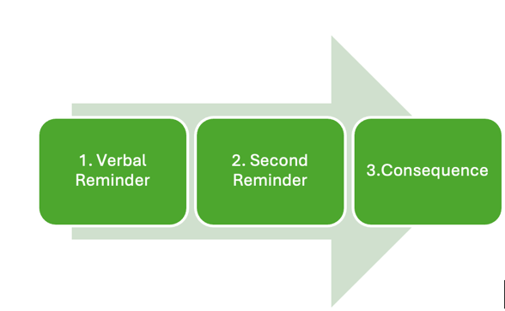
If a child displays persistent, low-level behaviour in the class, staff must take time to consider what the learning and teaching experience is like for the pupil, with a view to intervening with modifications using the following steps:
Step 1. Verbal Reminder. A reminder of the expectations. Repeat reminders if reasonable adjustments are necessary. Take the initiative to keep things at this stage.
Step 2. Second Reminder. A clear verbal caution is delivered wherever possible, making the student aware of their behaviour and clearly outlining the consequences if they continue.
Step 3. Consequence. This might be a short time outside the room if this is possible, or at the side of the playground. It is a period for the child to calm down, breathe, look at the situation from a different perspective and compose themselves.
This could also be Reflection Time. This might be a quick chat during the school day when you have a restorative chat with the child. The child is given reflection time (e.g., 5 minutes of thinking time, moving seat, or restorative conversation during break/lunch time (5-10mins) this will be relative to age and stage of pupil and decided by their teacher.
Serious Behaviour
Some behaviours are too serious for warnings and require immediate action, including intervention by SLT and a Parent Notification letter home. Examples of serious behaviour:
  - Physical aggression
  - Using offensive or inappropriate language
  - Open defiance or refusal to follow instructions
  - Fighting or deliberately hurting someone
  - Damaging school property on purpose
Response:
  - The Senior Leadership Team (SLT) is informed
  - Parent involvement: Parents will be contacted depending on the severity, this takes the form of the Working Together Letter
A reflective discussion follows to help the child understand what behaviour does not reflect the school values, and what is expected going forward. This may take the form of a restorative conversation. A parent being called is a serious consequence for behaviour.
Teachers must consider contacting the parents/carers if the child is consistently losing time during break due to behaviour. Staff should consult with SLT once they have a concern about the impact of this and agree to contact the parents/carers. This contact can be done by phone initially but is usually in the form of a Working Together Letter; these can be given after one serious incident, as well as after a series of low-level incidents that are not improving or reducing in frequency. See Appendix 1
3.3 Restorative Approach
We will use the questions below to support everyone in our school community to problem solve in a solution focused way. Restorative approaches are very effective as they provide a framework for adults and pupils to discuss what has happened. The impact or effect of this can plan a clear way forward together.
A restorative approach is all about relationships – making, maintaining, and, when necessary, repairing relationships. If a restorative conversation is needed, the class teacher will call for a member of the senior leadership team who can take their class to give the class teacher the opportunity to work through the questions 1:1 with the child.
What happens during a Restorative Conversation?
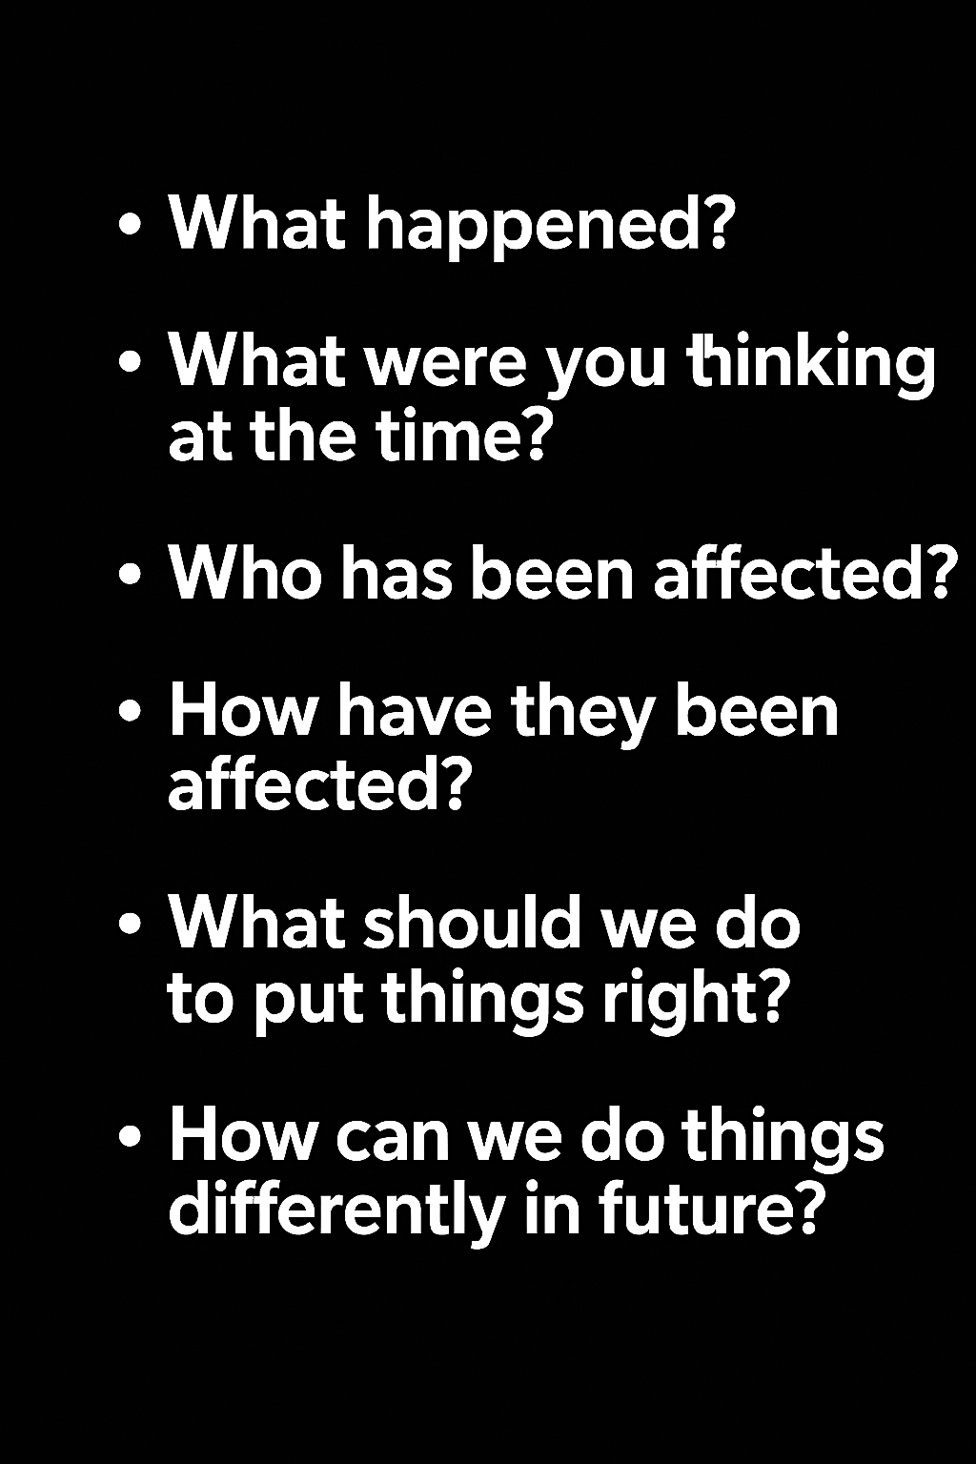

A restorative approach provides a framework of values, thinking and language that is helpful when ‘something’ needs to be restored. These conversations are entirely dependent on the individual situation. In different contexts, this could be:
- effective communication
- relationships or friendships
- empathy and understanding for another person’s perspective
- respect (this could mean a sense of security, self-confidence, self-respect, or dignity)
- understanding the impact of our own behaviour on others
- repairing or replacing damaged materials or resources
3.4 Natural Consequences
Natural consequences are a supportive and educational way to help children understand the impact of their actions. They are not punishments, but logical outcomes that relate directly to the behaviour shown.
Natural consequences are outcomes that:
- Relate clearly to the behaviour a child has shown.
- Help children connect their behaviour to its effect on others.
- Support children to learn, repair relationships, and make better choices next time.
- Encourage accountability in a fair, age-appropriate way.
They should never be arbitrary or rooted in adult power. Instead, they should:
- Link feelings to behaviour,
- Link behaviour to impact, and
- Provide a foundation for learning new behaviours.
Natural consequences help children understand cause and effect. They promote problem-solving and responsibility. These examples illustrate how consequences connect directly to the behaviour:
- If something is broken, the child helps repair it, replaces it, or manages without it.
- If someone’s feelings are hurt, the child apologises and takes steps to make amends.
- If behaviour is unsafe or inappropriate on a school trip, the child may be returned to school early or may not attend the next trip.
- If a child hurts someone in the playground, they may stay in for the next break to reflect and restore safety.
- If a game is spoiled, other children may choose not to play with them until trust is rebuilt.
- If a child hits someone, parents/carers will be contacted to discuss the behaviour and support needed to avoid future physical reactions directed towards others.
- If a class or lesson is disrupted, the child may move seat until they are regulated and ready to learn.
- If a child repeatedly talks over others during learning time, they may spend 5 minutes at break or lunch reflecting on how to improve.
- If a child stays up too late, they naturally feel tired the next day.
Some actions require more significant responses:
- A head teacher contacting parents is considered a serious consequence.
- When parents are asked to come to school to discuss behaviour, this reflects the seriousness of the situation.
- Spending part of break reflecting with the Senior Leadership Team is a serious consequence related to the impact of your behaviour on others.
3.5 Nurture
Nurture is both a universal and targeted approach at Lairdsland. A nurturing approach recognises that positive relationships are central to both learning and wellbeing. A key aspect of a nurturing approach is an understanding of attachment theory and how early experiences can have a significant impact on development. It recognises that all staff have a role to play in establishing positive relationships.

A nurturing approach has a key focus on the school environment and emphasises the balance between care and challenge which incorporates attunement, warmth and connection alongside structure, high expectations and a focus on achievement and attainment.

There are 6 Principles to a Nurturing Approach:

    - Children’s learning is understood developmentally.
    - The classroom offers a safe base.
    - The importance of nurture for the development of wellbeing.
    - Language is a vital means of communication.
    - All behaviour is communication.
    - The importance of transition in Children’s lives.
Nurture includes the setting of firm and clear boundaries, where adults model concern, care and compassion and take the time to build protective relationships. Within Lairdsland, these principles underpin our whole school approach to behaviour and relationships, as well as frame the targeted interventions for pupils that require extra support and space to build skills to manage school, friendships and learning.
3.6 The Circle Framework
It is the responsibility of all staff to consider their role when supporting a learner who finds participation and engagement difficult. All teachers use CIRCLE Framework to audit their classroom environment, ensuring it is inclusive for all.
For children with social and emotional needs, there can be barriers to learning, CIRCLE Participatory Scales are used to identify specific areas affecting individual pupils’ participation in the classroom. The information from completing these scales is then used to create targets on pupil support plans. We use the Up, Up and Away Resource for Early Years.
3.7 Trauma-Informed Approach
Like nurture, being trauma-informed underpins our approach to behaviour and relationships and also frames targeted interventions for pupils and families who have experienced trauma in their lives. The impact of trauma, stress, attachment, and Adverse Childhood Experiences (ACEs) is being increasingly better understood and included in approaches to managing behaviour.

Experiences such as neglect, abuse, poverty, loss, and violence can result in children developing coping strategies to manage the difficult feelings this can lead to. These coping strategies can be challenging, difficult to manage, harmful to themselves and others as well as distressing to deal with.
We aim to deal with this distressing behaviour by helping children learn new ways to deal with difficult feelings.

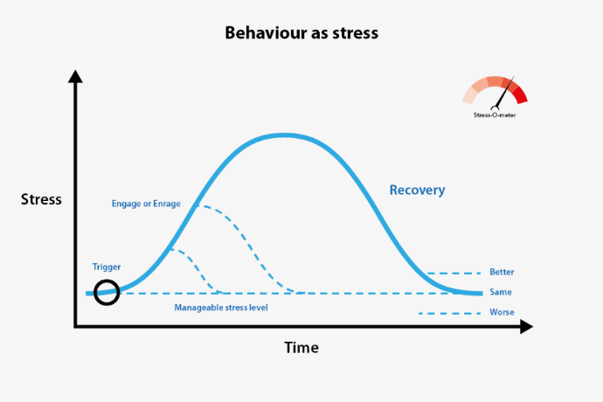

We see behaviour as an indicator of stress and recognise that when behaviour is escalating, stress levels are increasing. Our approach is to reduce stress levels and then deal effectively with behaviour.
Staff are trained in de-escalation techniques and have an awareness of how body language and tone of voice influence stressful situations. We will always seek to reduce stress and in doing so, are modelling and teaching the children new coping mechanisms to deal with difficult feelings. Once children are regulated and calm, we can then deal with the impact of their behaviour. Sometimes, this may need to be the next day. We ‘strike while the iron is cold’.

3.8 Anti-Bullying

‘Children who are bullied do not feel like themselves, they feel like they have something taken away from them. They feel they lose the ability to manage what is happening to them and worry a great deal about what might happen if they tell, if they speak up or if they ignore it.’ (Brian Donnelly 2021 https://orbistc.com/anti-bullying/).

What you do about bullying is more important than how you define it

The Scottish Government defines bullying as ‘face-to-face and/or online behaviour which impacts on a person’s sense of physical and emotional safety, their capacity to feel in control of their life and their ability to respond effectively to the situation they are in’ (Respect for All: National Approach to Anti-Bullying for Scotland’s Children and Young People, Scottish Government 2024)

We do not try to figure out if it was bullying before responding. We act as soon as something happens. Our staff will respond to any concerns or allegations of bullying by asking:
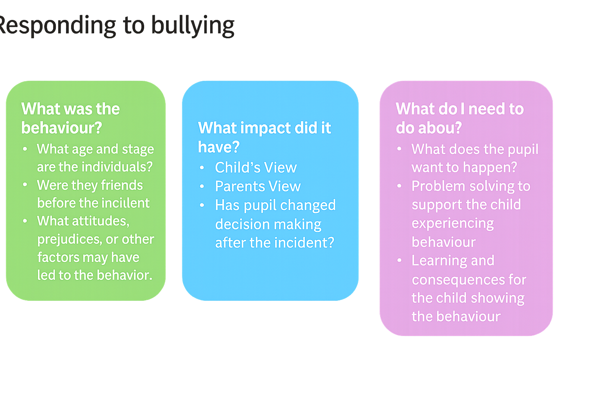

This is helpful as it breaks incidents and allegations down into a manageable, solution-focused process. All staff can respond to bullying and must always share this with the Leadership Team for advice, support and guidance.

Online bullying is the same type of behaviour, but it takes place online, usually on social networking sites or in group chats. A person can be called names, threatened, or have rumours spread about them online and in group chats. Unkind and hurtful comments in group chats are just as serious as those made face-to-face.

It is the responsibility of parents and carers to teach their children how to behave online and how to safely use social media and devices. It is for parents and carers to set limits on screen time, what content they can access, and to follow the expectations on the use of mobile phones in schools. Incidents we become aware of between pupils that happen online or out of school will always require parental involvement. In most situations, negative interactions online that take place outside of school hours are not for the school to address.

- Targeted Approaches
When our Universal Approaches are not appropriate for some children, we have a process to identify and plan targeted interventions at Lairdsland. In collaboration with parents and carers, we will undertake a Wellbeing Assessment and, if all supports offered do not provide the anticipated impact, the school will seek further advice at a Pupil Support Group (PSG).
This includes the class teacher, the Depute Head Teacher and an Educational Psychologist. Sometimes the Speech a Language Specialist will also attend. Advice will be given and a plan put in place. The next stage can be a Targeted Action Plan, setting out what strategies are in place and what will be monitored. Parents/carers will receive feedback and a plan agreed. There may also then be a Team around the Child (TAC) meeting.
4.1 Nurture Class
We offer small groups and individuals, targeted nurture-based support and set out agreed outcomes with families to support behaviour and relationships at school and at home. This is based on Wellbeing Assessments and discussion with families.
4.2 Family Learning Services
Our Family Learning Assistant provides a range of supports and programmes for parents, carers and children, including
- Parents coffee morning  - Uniform Bank  - Family Cooking Sessions  - Foodbank | - Wellbeing Wednesdays  - Families Connect P1 & 2  - Lego Therapy Club
4.3 We also have a range of targeted resources we can access at Lairdsland
- Wellbeing Support Service  - Life-Link Counselling  - Seasons 4 Growth | - LIAM (Anxiety Management)  - Nurture Outreach  - WFWF (Whole Family Wellbeing Fund)
- Celebrating Success
House Points
House Points are awarded for pupils demonstrating the school values, and also for success at school sports day. They are celebrated at assemblies.

Certificates
Pupils can nominate other pupils and/or adults for a Hot Chocolate Award for displaying the school values. Teachers will give Star Awards weekly to recognise pupils who demonstrate effort, perseverance and a positive attitude towards their learning.
- Roles and Responsibilities
6.1 The Role of our Staff
All Staff play a crucial role in setting clear expectations and modelling positive behaviour. They are responsible for:
- Demonstrating the values of Welcoming, Kindness, and Teamwork
- Establishing a safe, inclusive, and respectful learning environment
- Building positive relationships across the school community
- Clearly communicating behaviour expectations using our shared language
- Encouraging and celebrating positive behaviour through class and whole-school rewards
- Supporting pupils in reflection and improvement following misbehaviour
- Working with parents, partners and SLT when further intervention is needed
6.2 The Role of the Pupil
Pupils are expected to take responsibility for their behaviour and contribute to a positive school environment by:
- Demonstrating the values of Welcoming, Kindness, and Teamwork
- Respecting others’ rights to learn and play safely
- Making good choices, even when faced with challenges
- Accepting consequences with a willingness to reflect and improve
- Supporting their peers by encouraging positive behaviour and reporting concerns if needed
- Working hard in class
6.3 The Role of the Parent/Carer
Parents and carers are key partners in promoting good behaviour. Their role includes:
- Reinforcing school values at home and supporting the behaviour and relationships policy
- Encouraging their child to reflect on their choices and take responsibility for their actions
- Celebrating their child’s successes and praising positive behaviour
- Communicating any concerns with the teacher and working together to support their child
- To support their child in using technology and social media responsibly
- Attending meetings when needed to discuss and support their child’s behaviour
- We ask parents to be ‘curious, not furious’ when exploring issues at school.
We believe that creating a safe, respectful, and supportive environment is a shared responsibility. When teachers, parents, and pupils work together and model our core values, children are more likely to develop them in a meaningful way.
This policy will be reviewed by 2029.

Appendix 1. Working Together Letter

Lairdsland Primary School

Our Values: Welcoming Kindness Teamwork

Working Together to Support ……………………………………. Date ………………….

Dear Parent/Carer,

We are contacting you as part of our commitment to working in partnership with parents and carers to support every child’s wellbeing, relationships and behaviour. We aim to ensure that all pupils feel safe, included and supported to learn and reach their full potential

We have been supporting your child following an incident today
Details

Staff supported your child to take time to feel calm before talking through what happened.

Once they were ready, we had a restorative conversation with your child. This gave them the opportunity to think about:
- what happened and how they were feeling at the time;
- how their actions may have affected others;
- what they could do differently in the future; and
- what support might help them make positive choices.

As part of this, we agreed that keeping you informed and working together would help us to continue to support your child. We would really value your support in talking with your child, encouraging them to think about what they have learned and what they can do next time they find themselves in a similar situation.

Please sign and return the tear-off slip below. Should you feel you wish to discuss the matter further, please do not hesitate to contact us at school.

Pupil’s signature …………………………………Date ……………………

Class Teacher’s Signature ………………………………………. SLT’s Signature …………………………………………………….
--------------------------------------------------------------------------------------------------------------------------------------------------
Parental Notification – Working Together to Support Your Child.

I acknowledge receipt of the above and have discussed it with my child:

Pupil’s name…………………………………………… Signed………………………………………………………………….

Comment
This letter reflects our school values and our commitment to working together with our families. It shares details of what happened and invites parents and carers to support the response, as well as to ask questions or share any concerns.
Staff will describe the behaviour that has led to the letter home and ensure that our values of Welcoming, Kindness and Teamwork are reflected in how we communicate.
These letters can be given after one serious incident, as well as after a series of low-level incidents that are not improving or reducing in frequency.

